

**Politecnico di Milano**  
Dipartimento di Scienze e Tecnologie Aerospaziali  
Prova finale: Introduzione all’Analisi di Missioni Spaziali  
Docente: Massari Mauro

Elaborato n. C13

Autori:

|  |  |
| --- | --- |
| 10694997 | Pala Silvia |
| 10711624 | Turcu Alex Cristian |
| 10730510 | Vanelli Paolo |

Anno Accademico 2022-2023

Data di consegna: 04/01/23

# Table of contents

Table of contents 2

1 Introduction 3

2 Initial orbit characterisation 4

2.1 Initial orbital parameters 4

2.2 Data interpretation 4

2.3 Graphical representation 4

3 Final orbit characterisation 5

3.1 Final orbital parameters 5

3.2 Data interpretation 5

3.3 Graphical representation 5

4 Transfer trajectory definition and analysis 6

4.1 Standard strategy 6

4.2 Other standard strategies and decision explanation 6

4.3 Alternative strategy 1 7

4.4 Alternative strategy 2: secant strategy 7

4.5 Alternative strategy 3: tangent strategy 8

5 Conclusion 11

6 Appendix 12

6.1 Standard strategies tables 12

6.2 Alternative strategies tables 15

6.3 Other plots and graphics 16

# Introduction

The aim of this project is to study, to optimise and to choose various orbital transfer strategies, having as initial data:

* a point on the initial orbit, whose position and velocity vectors are given
* a point on the final orbit, which is defined by its orbital parameters.

Firstly, some strategies based on a set of standard manoeuvres will be analysed, then they will be discussed and compared in order to select the best compromise between the two most significant parameters:

* the manoeuvring cost (the total speed gap required to complete all the orbital changes)
* the operating time (from the start point to the final point).

Furthermore, some alternative strategies – that include manoeuvres that are not involved in the standard ones – have been projected with the intent to minimise the parameters previously described.

All calculations and plots were made using MATLAB software.

# Initial orbit characterisation

## Initial orbital parameters

The assigned starting position and velocity vectors are the following ones:

$$r_{i}=\left[\begin{matrix}-1169.7791 \\ -8344.5289 \\ 977.8062\end{matrix}\right] km v_{i}= \left[\begin{matrix}4.2770 \\ -1.9310 \\ -4.9330\end{matrix}\right] {km}/s$$

It is possible to calculate the orbital parameters assigned to this specific couple of vectors:

|  |  |  |  |  |  |
| --- | --- | --- | --- | --- | --- |
| $$a_{i} [km]$$ | $e_{i}$ [-] | $$i_{i} [rad]$$ | $Ω_{i}$ $[rad]$ | $$ω_{i} [rad]$$ | $θ_{i}$ $[rad]$ |
| 8369.7448 | 0.1097 | 0.8487 | 1.5339 | 1.1849 | 1.8025 |

## Data interpretation

The starting geocentric orbit is elliptical, with an eccentricity value between 0 and 1 and a specific energy of:

$$E_{i}= -\frac{μ}{2a_{i}}= -23.8119 {km^{2}}/{s^{2}}$$

where $μ$ is the standard gravitational parameter of the Earth. It belongs to Medium Earth Orbit (MEO) category, as its apogee and its perigee are inside the range of 8000 - 42000 km:

$$ra_{i}= 9288 km$$

$$rp_{i}=7452 km$$

According to the given value, it is nor a polar nor a geo-synchronous orbit and has a period of:

$$T_{i}=7620 s=2 h, 7 m, 0 s$$

## Graphical representation

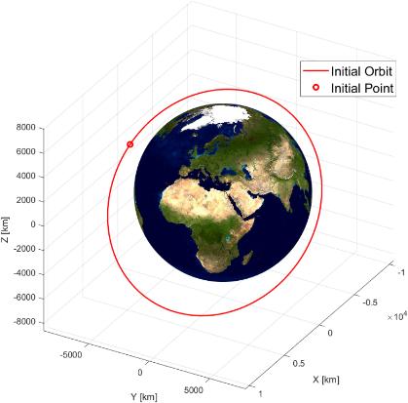

Figure 1 - Initial orbit

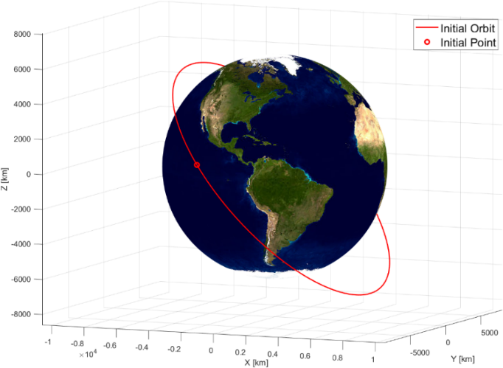

Figure 2 - Initial orbit

# Final orbit characterisation

## Final orbital parameters

The goal orbit, that is geocentric just like the starting one, is defined by its orbital parameters:

|  |  |  |  |  |  |
| --- | --- | --- | --- | --- | --- |
| $$a_{f} [km]$$ | $e_{f}$ [-] | $$i_{f} [rad]$$ | $Ω_{f}$ $[rad]$ | $$ω_{f} [rad]$$ | $θ_{f}$ $[rad]$ |
| 10860 | 0.2332 | 0.5284 | 3.0230 | 0.4299 | 0.3316 |

The final position and velocity vectors are calculated from these parameters:

$$r_{f}=\left[\begin{matrix}-6640.6 \\ -4258.2 \\ 2927.0\end{matrix}\right] km v_{f}= \left[\begin{matrix}4.2742 \\ -5.5798 \\ 2.9393\end{matrix}\right] {km}/s$$

## Data interpretation

The final geocentric orbit is elliptical, with an eccentricity value between 0 and 1 and a specific energy of:

$$E_{f}= -\frac{μ}{2a_{f}}= -18.3517 {km^{2}}/{s^{2}}$$

It belongs to Medium Earth Orbit (MEO) category, as its apogee and its perigee are inside the range of 8000 – 42000 km:

$$ra_{f}=13393 km$$

$$rp_{f}=8327 km$$

According to the given value, it is nor a polar nor a geo-synchronous orbit and has a period of:

$$T_{f}=13423 s=3 h, 43 m, 43 s$$

## Graphical representation

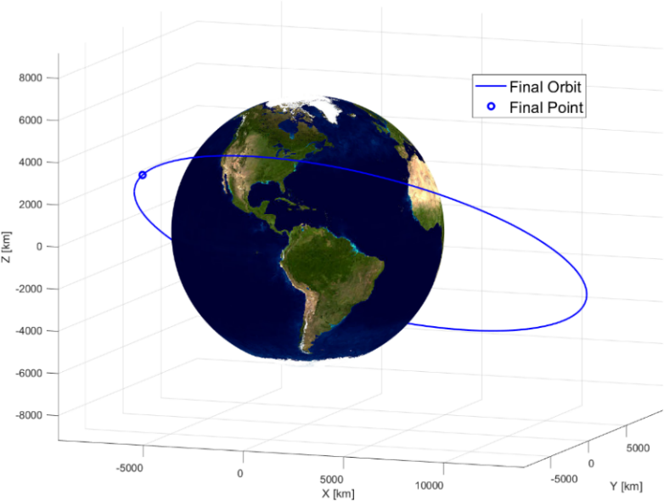

Figure 3 - Final orbit

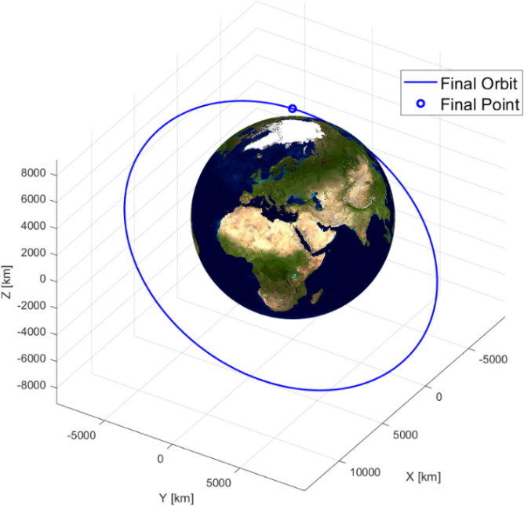

Figure 4 - Final orbit

# Transfer trajectory definition and analysis

## Standard strategy

It is possible to reach the assigned final point on the final orbit starting from the initial point on the initial orbit through a standard strategy, which uses a permutation of three standard manoeuvres. The standard strategy that has been chosen is sequentially composed by a bitangent transfer from perigee to apogee, a change of the orbital plane and a change of the argument of perigee. The data concerning these manoeuvres can be found in Table S.1.

Each manoeuvre changes a specific set of orbital parameters.

1. Bitangent manoeuvre: to perform this manoeuvre, it is necessary to first reach the initial orbit perigee, where the initial burn is made. This burn transfers the satellite on a new orbit, that compared to the previous one has a different semi-major axis and a different eccentricity. Once the apogee of the transfer orbit is reached, the satellite is transferred to a third orbit through another burn. This orbit has the same semi-major axis and the same eccentricity of the assigned final orbit.

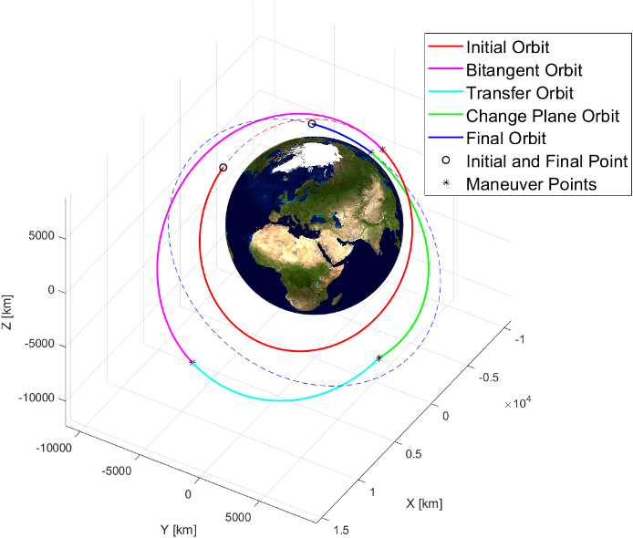

Figure 5 - Standard strategy 1

1. Change of orbital plane: it is necessary to change the inclination of the current orbital plane to the final one. Through this manoeuvre, which is realised in the point that needs the minor $Δv$, the final inclination and final RAAN can be achieved.
2. Change of argument of perigee: in order to reach the configuration of the final orbit it is necessary to vary the argument of perigee through a final burn. Then, the final point is reached after a short course on the final orbit.

## Other standard strategies and decision explanation

Among the possible permutation, it has been chosen to perform the strategy as previously described. This strategy has been selected since it has the lowest cost in term of speed gap, up to 27.3% lower than the other strategies (Tables from S.2 to S.8). This result can be achieved with some precautions, such as making sure not to change the orbital plane as first manoeuvre and to do it later in the furthest point possible, as in the strategies described in the Tables S.1, S.4, S.5, S.6, saving up to 13.6% of $Δv$ used for the plane change.

Furthermore, it can be seen that in the chosen bitangent manoeuvre the cost is minimised if it is done from perigee to apogee. Indeed, there is a reduction in $Δv$ of 2.15% compared to the manoeuvre done from apogee to perigee, and up to 34.7% compared to the other manoeuvres. By doing the bitangent manoeuvre before the change of the orbital plane, there are no significant benefits in terms of $Δv$.

The time required by the proposed strategy is 21.1% higher than the other strategies, as shown in Table S.9. It is greater because the covered orbits are wider in order to reduce $Δv$. The cost associated with the change of perigee argument is 47.6% greater than the lowest one. Despite this fact, the total cost of the strategy remains the most convenient.

As it can be seen in Table S.9, the strategies S.2 and S.8 are also notable for its reduced time, which are the lowest among the possible standards.

## Alternative strategy 1

The first alternative strategy is based on the use of a circular auxiliary orbit with the same radius as the apogee of the final orbit.

This choice was made to avoid the manoeuvre necessary to change the argument of perigee, passing from the circular orbit to the final orbit adjusting only the semi-major axis and the eccentricity.

All the values of the circular orbits were kept as if it was elliptical for simplicity of the data management.

The strategy starts with a bitangent transfer from the perigee of the initial orbit to the circular transfer orbit, whose radius is equal to the apogee of the final orbit.

After that, a change of plane is realised to obtain the same circular orbit on the final orbital plane.

In terms of $Δt$, it is more convenient to perform the change of plane in the first point possible, since $Δv$ does not change between the two intersections due to the circularity of the orbit.

Once that the intersection between the circular orbit and the apogee of the final orbit is reached (after nearly a full period on the circular orbit), the last burn is given to enter the final orbit, so that the satellite can arrive to the final point.

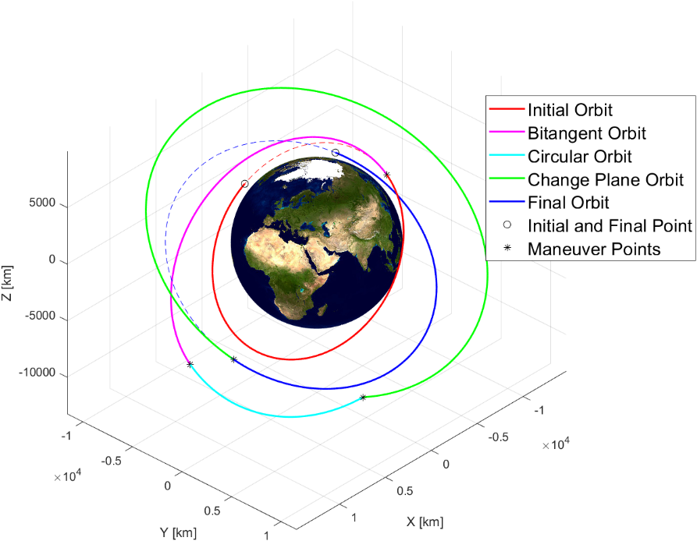

Figure 6 - Alternative strategy 1

As it could be seen in Figure 6, the orbits that the satellite must cover are much wider than the ones in the proposed standard strategy, resulting in a time-increment of 85%.

This strategy has a 6.7% lower cost of the manoeuvre of plane change, in comparison to the chosen standard. However, all the other manoeuvres make this strategy globally more expensive.

## Alternative strategy 2: secant strategy

The second alternative strategy is a two-burn manoeuvre that has been chosen as the best compromise between the total cost and the total time. In order to find the manoeuvre, it firstly has to be searched the two-burn manoeuvre that is able to minimise as much as possible the total cost (Table A.5, Figure 14). This manoeuvre has been realised through a MATLAB function that is able to return a set of possible secant manoeuvres (these ones discretise an infinite range of manoeuvres), given the initial point and the final point of the manoeuvre. Indeed, the burns can be arbitrarily directed into space: only the orbital plane remains constant, since it is the only one passing through the three known points (the initial and the final ones and the focus of the orbit). Therefore, the parameters $i, Ω, u_{i}, u_{f}$ remain unchanged, while the parameters $a, e, ω, θ_{i}, θ_{f}$ will vary according to a chosen parameter.

So, the problem is underdetermined and therefore there are infinite orbits that can solve the problem: it is convenient to parametrise the argument of perigee $ω$ by discretising the range between 0 and $2π$, selecting successively the valid orbits. To do this, it has been used MATLAB to study the eccentricity as a function of $ω$ through its graph (Figure 7); the shape of the latter remains similar for all the cases analysed, as it always has just one range of $ω$ for which the eccentricity is acceptable (between 0 and 1).

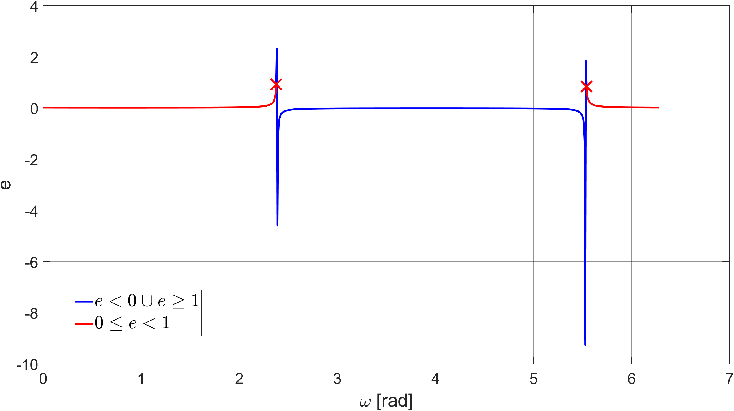

Figure 7 - Graph of eccentricity as a function of ω

By isolating the range and discretising it, it is possible to determine the remaining orbital parameters, to define a set of orbits passing through two points and to calculate the cost and the time of the various orbital transfers.

By using the function described above, it has been defined an iterative process consisting of two nested for-loops that can vary the initial and the final points, discretising the initial and the final orbits through their orbital parameters; among the analysed orbits, it has been found the one with the lowest total cost.

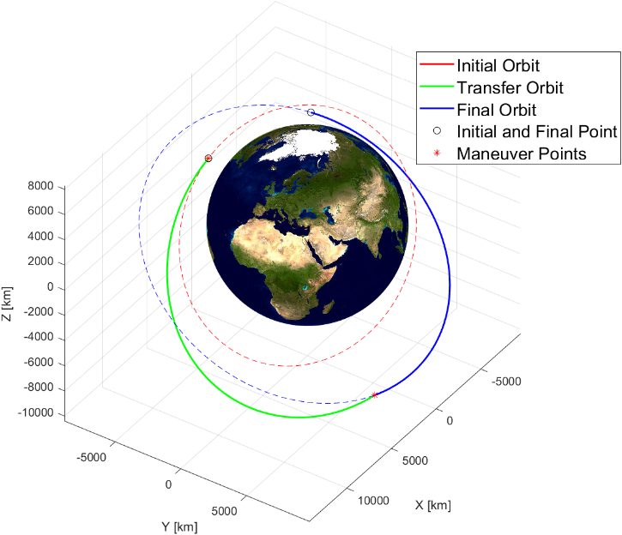

Figure 8 - Secant strategy

Starting from this orbit, it can be realised that the point of manoeuvre that has been chosen on the initial orbit is slightly rear from the initial point, and that the greatest amount of time used by the satellite is spent on the course the satellite accomplishes on the initial orbit (almost an entire orbital period). By knowing this, the initial point of manoeuvre has been fixed on the starting point, and the code has been re-adjusted by varying only the point on final orbit within the loop. The result is a secant transfer, whose total time is about halved (reduced by 46.96% compared to the previous one), while the total cost is increased by only 1.54%.

## Alternative strategy 3: tangent strategy

The last alternative strategy idea was to take advantage from the capability of a tangent manoeuvre to change all the orbital parameters (inclination ones excluded): therefore, the entire structure of this strategy has been projected to condense in a single manoeuvre the change of argument of perigee and the distancing from the main attractor (which is necessary to contain the cost of the subsequent orbital inclination change). The outcome of these first two manoeuvres will be an orbit in the same plane of the final orbit and, as previously planned, with the same argument of perigee that the final orbit has. In order to fix the semi-major axis and the eccentricity (the only parameters that differ between the current and the final orbit), a bitangent transfer will be performed from the apogee of the first orbit to the perigee of the second orbit.

The main difficulty in the design of this strategy is to obtain the desired change of argument of perigee during the tangent manoeuvre. It is easier to find the argument of perigee value needed in the plane of the initial orbit by proceeding backwards. By knowing the inclination and the RAAN of the two orbital planes and the argument of perigee of the final orbit, it is possible to obtain information about the initial argument of perigee and about the two manoeuvring angles:

Case with $ΔΩ>0, Δi<0$:

$$α=\cos^{-1}\left(\cos{i_{i}}\cos{i_{f}}+\sin{i_{i}}\sin{i_{f}}\cos{ΔΩ}\right)$$

$$\sin{u_{i}}=\frac{\sin{ΔΩ}}{\sin{α}}\sin{i_{f}}; \cos{u_{i}}=\frac{\cos{i_{f}}-\cos{α}\cos{i_{i}}}{\sin{α}\sin{i_{i}}} \underset{⇒}{ } u_{i}=atan2\left(\sin{u_{i}},\cos{u_{i}}\right)$$

$$\sin{u_{f}}=\frac{\sin{ΔΩ}}{\sin{α}}\sin{i_{i}}; \cos{u_{f}}=\frac{-\cos{i_{i}}+\cos{α}\cos{i_{f}}}{\sin{α}\sin{i_{f}}} \underset{⇒}{ } u_{f}=atan2\left(\sin{u_{f}},\cos{u_{f}}\right)$$

$$θ_{1}=2π-u_{f}-ω_{f} ; ω_{i}=2π-u_{i}-θ_{1} ; θ_{2}=θ_{1}-π$$

Since the transverse orbital speed is lower at $θ_{1}$ (which is in the quadrant III), it has been selected to be the point where the orbital inclination change maneuver will be performed. After obtaining the information on the argument of perigee that should be reached in the initial orbital plane, it is necessary to design the tangent manoeuvre to achieve this value. Since the problem is under determined - and therefore infinite manoeuvres exist – it is chosen to parametrise the tangent burn $Δv$; a function has been defined in MATLAB to numerically solve the following system (simplified in an analytic way solving for $θ_{tan}$):

$$\left\{\begin{aligned}Δv=\sqrt{2μ\left(\frac{1}{r}-\frac{1}{2a_{tan}}\right)}-\sqrt{2μ\left(\frac{1}{r}-\frac{1}{2a_{i}}\right)} \\ r=\frac{a_{i}\left(1-e_{i}^{2}\right)}{1+e_{i}\cos{θ_{i}}}=\frac{a_{tan}\left(1-e_{tan}^{2}\right)}{1+e_{tan}\cos{θ_{tan}}} \\ \tan{γ}=\frac{e_{i}\sin{θ_{i}}}{1+e_{i}\cos{θ_{i}}}=\frac{e_{tan}\sin{θ_{tan}}}{1+e_{tan}\cos{θ_{tan}}} \\ ω_{i}-ω_{tan}=θ_{tan}-θ_{i}\end{aligned}\right. {Known parameters: a_{i},e_{i},ω_{i},ω_{tan},μ,Δv \atop Variables: a_{tan},e_{tan},θ_{tan},θ_{i}}$$

$$\left\{\begin{aligned}θ_{i}\left(θ_{tan}\right)=θ_{tan}+ω_{tan}-ω_{i} \\ \tan{γ}\left(θ_{tan}\right)=\frac{e_{i}\sin\left(θ_{i}\left(θ_{tan}\right)\right)}{1+e_{i}\cos\left(θ_{i}\left(θ_{tan}\right)\right)} \\ r\left(θ_{tan}\right)=\frac{a_{i}\left(1-e_{i}^{2}\right)}{1+e_{i}\cos\left(θ_{i}\left(θ_{tan}\right)\right)} \\ e_{tan}\left(θ_{tan}\right)=\frac{\tan{γ}\left(θ_{tan}\right)}{\sin{θ_{tan}}-\cos{θ_{tan}}\tan{γ}\left(θ_{tan}\right)} \\ a_{tan}\left(θ_{tan}\right)=r\left(θ_{tan}\right)\frac{1+e_{tan}\left(θ_{tan}\right)\cos{θ_{tan}}}{1-e_{tan}^{2}\left(θ_{tan}\right)} \\ Δv=\sqrt{2μ\left(\frac{1}{r\left(θ_{tan}\right)}-\frac{1}{2a_{tan}\left(θ_{tan}\right)}\right)}-\sqrt{2μ\left(\frac{1}{r\left(θ_{tan}\right)}-\frac{1}{2a_{i}}\right)}\end{aligned}\right.$$

The result is a single nonlinear equation that can be studied and solved by using a numerical method similar to the one used on the eccentricity graph of the previous strategy: it always has two solutions, but only one can be considered acceptable (since the other one returns a negative eccentricity) or none (for too high values of the parameter ).

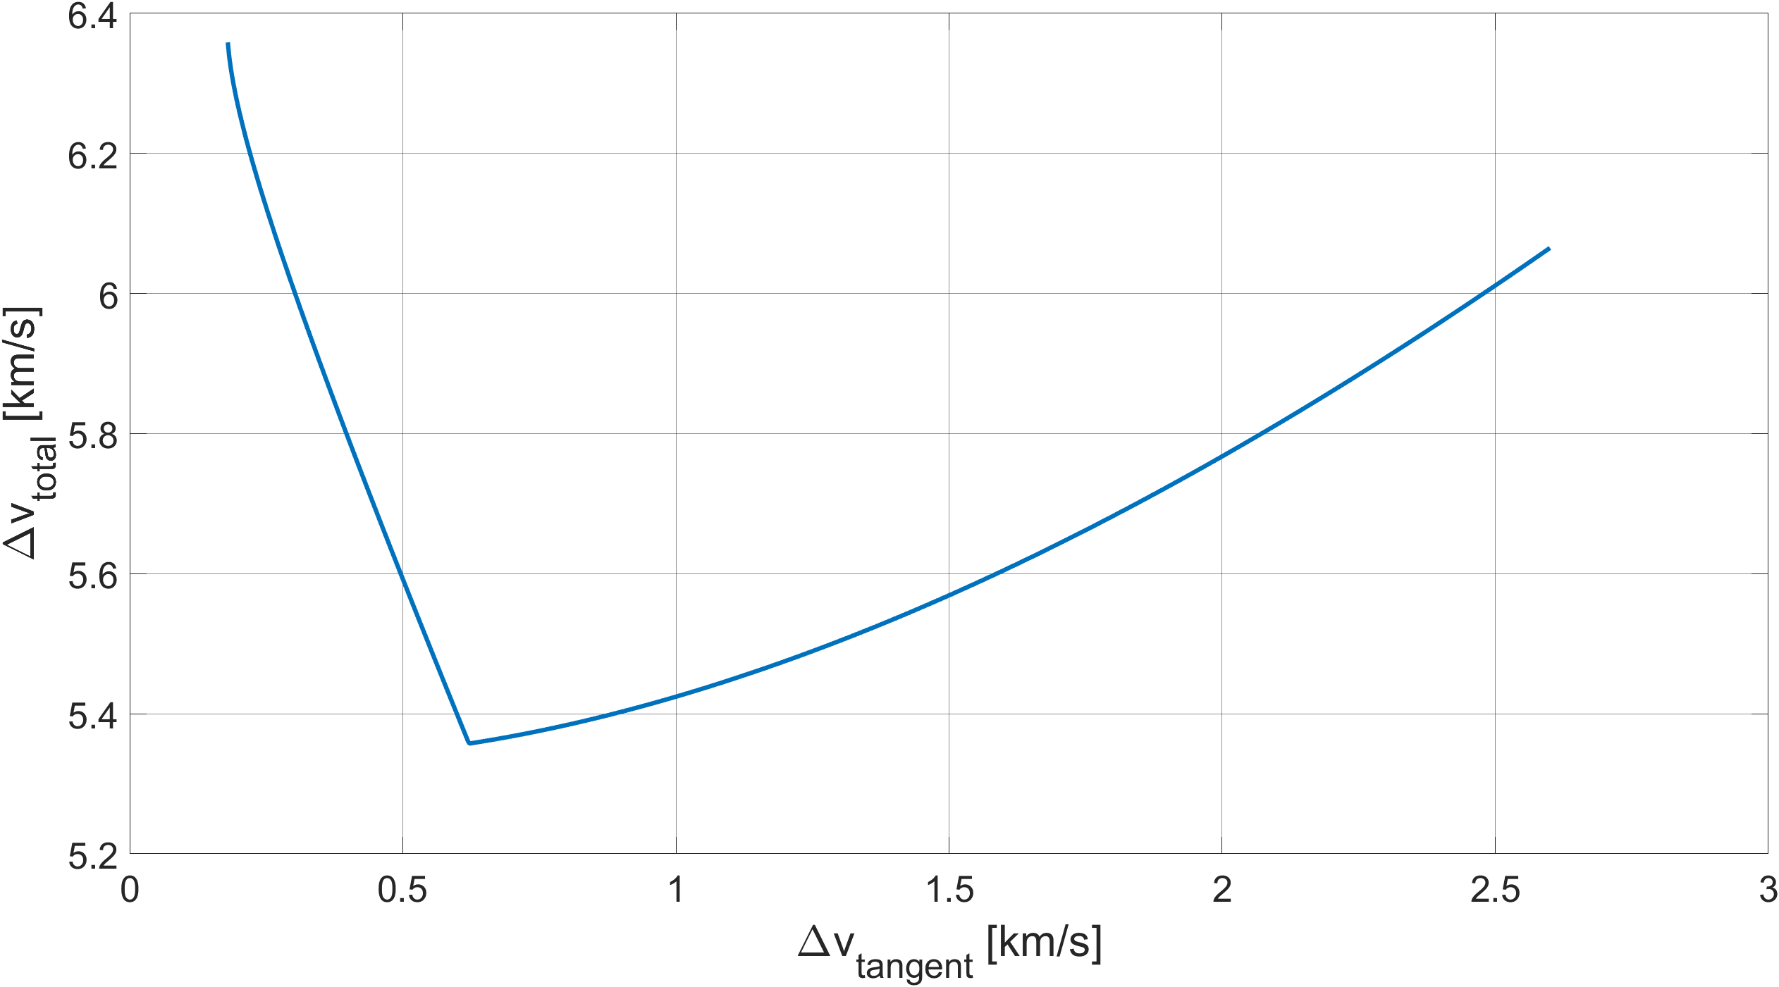

Figure 9 - Total cost of the strategy

By choosing an acceptable initial burn value, the strategy is completely defined, and it is concluded after the change of orbital plane by a simple bitangent manoeuvre from apogee to perigee: therefore, the software MATLAB has been used to obtain the plot of the total cost of the strategy as a function of the tangent burn, and it is chosen the value by which such cost is minimised.

From the data reported in the Table A.3 it is also possible to observe that the second burn of the last manoeuvre is really small, because the two orbits are almost perfectly identical after a single-burn manoeuvre in the apogee: therefore, it can be deduced (the demonstration is not subject of this short relation) that the optimal strategy would be to fix the point of intersection between the plane-change orbit and the final one in their apogees, so as to adjust the semi-major axis and the eccentricity with a single burn. This constraint would make the strategy unique and fully defined by its equations.

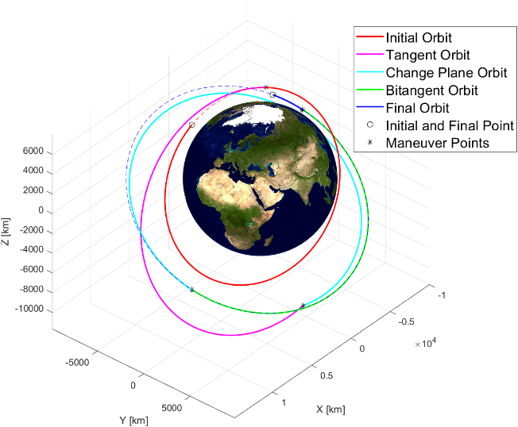

Figure 10 - Tangent strategy

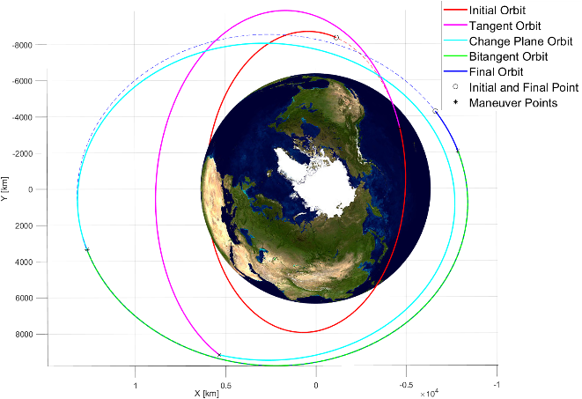

Figure 11 - Tangent strategy

# Conclusion

After comparing and choosing the best possible standard strategy and analysing various alternative strategies, it is possible to make considerations on operating time and cost (Figure 12).

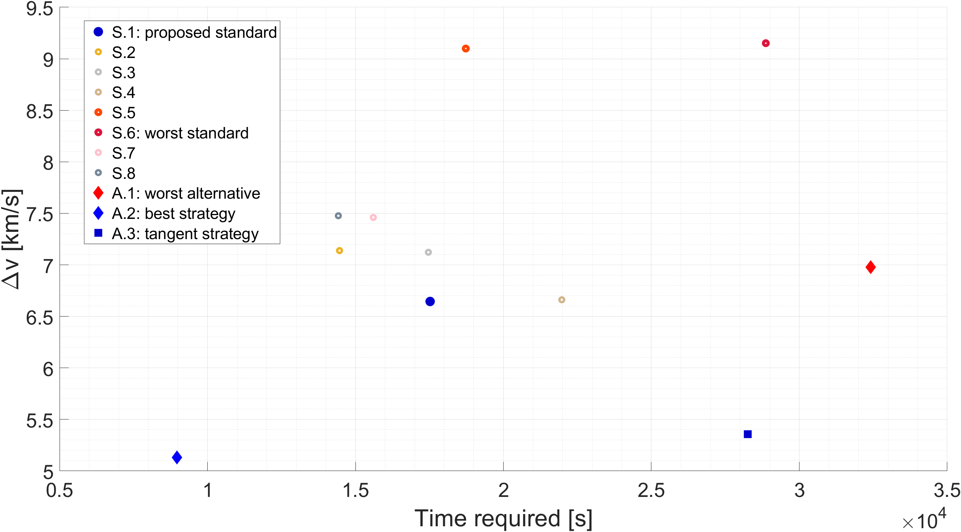

Figure 12 - Comparison of strategies

As it can be noted in the tables in the Appendix, for each strategy the cost associated with coplanar maneuvers is always lower than the cost of change of the orbital plane, because of the similarities in shape and dimension of the two assigned orbits. Indeed, the cost related to the change of orbital plane manoeuvres is predominant (for instance, this cost results up to 78% of the total in the standard strategy), due to the difference in inclination of 18.3493° between the two orbital planes and the nearness of the main attractor.

As it could be seen in the graphic above (Figure 12), the best strategy in terms of $Δv$ is the secant strategy, in which both time and cost are low due to the freedom given by the chosen method. In fact, direction and modulus of the $Δv$ vector can be decided (unlike the standard maneuvers), allowing to project an ad hoc strategy to minimise the total $Δv$.

Another viable option in terms of $Δv$ is the tangent strategy, which presents a reduction in cost of 19.37% compared to the standard strategy: this is due to the convenience of the change of plane, in which the burn is made on an orbit with higher eccentricity and further from the main attractor.

By knowing the angle in which the change of orbital plane is performed, the cost of this manoeuvre grows as well as the transversal speed, that lowers at the increment of the semi-major axis and of the eccentricity. Since the point of the first burn lays in the quadrant I, its increment implies the growth of both the semi-major axis and the eccentricity, and therefore a decrease in the cost of the change of plane. The cost has been graphed as a function of the initial burn in Figure 13.

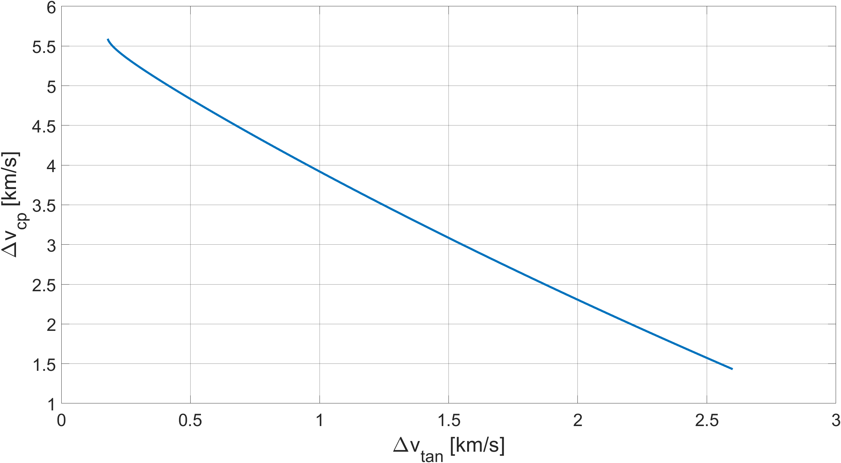

Figure 13 - Cost of plane change as a function of initial burn

Alternative strategy 1 provides no benefit due to the shapes and dimensions of the transfer orbits.

Both S.1 and S.4 are viable strategies, as the $Δv$ required is similar. However, the shape of the orbits covered by the satellite affects negatively the time required by S.4, making S.1 the best option.

# Appendix

## Standard strategies tables

**S.1: Standard strategy 1 (bitangent PA - change plane - change argument of perigee)**

|  |  |  |  |  |  |  |  |
| --- | --- | --- | --- | --- | --- | --- | --- |
| $t$ [s] | $a$ [km] | $e$ [-] | $i$ [rad] | $Ω$ [rad] | $ω$ [rad] | $θ$ [rad] | $Δv$ [km/s] |
| 0 | *8369.7488* | *0.1097* | *0.8487* | *1.5339* | *1.1849* | *1.8025* | - |
| 5697.7605 | *8369.7488* | *0.1097* | *0.8487* | *1.5339* | *1.1849* | *0* | 0.5863 |
| *10422.1787* | *0.2850* | *0.8487* | *1.5339* | *1.1849* | *0* |
| 10992.1880 | *10422.1787* | *0.2850* | *0.8487* | *1.5339* | *1.1849* | *3.1416* | 0.1642 |
| *10860* | *0.2332* | *0.8487* | *1.5339* | *1.1849* | *3.1416* |
| 14115.3731 | *10860* | *0.2332* | *0.8487* | *1.5339* | *1.1849* | *4.4179* | 5.1840 |
| *10860* | *0.2332* | *0.5284* | *3.0230* | *6.2190* | *4.4179* |
| 16892.4727 | *10860* | *0.2332* | *0.5284* | *3.0230* | *6.2190* | *0.2470* | 0.7105 |
| *10860* | *0.2332* | *0.5284* | *3.0230* | *0.4299* | *6.0362* |
| 17523.1496 | *10860* | *0.2332* | *0.5284* | *3.0230* | *0.4299* | *0.3316* | - |

**S.2: Standard strategy 2 (change plane - change argument of perigee - bitangent AP)**

|  |  |  |  |  |  |  |  |
| --- | --- | --- | --- | --- | --- | --- | --- |
| $t$ [s] | $a$ [km] | $e$ [-] | $i$ [rad] | $Ω$ [rad] | $ω$ [rad] | $θ$ [rad] | $Δv$ [km/s] |
| 0 | *8369.7488* | *0.1097* | *0.8487* | *1.5339* | *1.1849* | *1.8025* | - |
| 3695.7504 | *8369.7488* | *0.1097* | *0.8487* | *1.5339* | *1.1849* | *4.4179* | 5.9993 |
| *8369.7488* | *0.1097* | *0.5284* | *3.0230* | *6.2190* | *4.4179* |
| 5937.1528 | *8369.7488* | *0.1097* | *0.5284* | *3.0230* | *6.2190* | *0.2470* | 0.3724 |
| *8369.7488* | *0.1097* | *0.5284* | *3.0230* | *0.4299* | *6.0362* |
| 9986.7633 | *8369.7488* | *0.1097* | *0.5284* | *3.0230* | *0.4299* | *3.1416* | 0.1886 |
| *8807.5701* | *0.0545* | *0.5284* | *3.0230* | *0.4299* | *3.1416* |
| 14099.8266 | *8807.5701* | *0.0545* | *0.5284* | *3.0230* | *0.4299* | *0* | 0.5784 |
| *10860* | *0.2332* | *0.5284* | *3.0230* | *0.4299* | *0* |
| 14461.7429 | *10860* | *0.2332* | *0.5284* | *3.0230* | *0.4299* | *0.3316* | - |

**S.3: Standard strategy 3 (change plane - change argument of perigee - bitangent PA)**

|  |  |  |  |  |  |  |  |
| --- | --- | --- | --- | --- | --- | --- | --- |
| $t$ [s] | $a$ [km] | $e$ [-] | $i$ [rad] | $Ω$ [rad] | $ω$ [rad] | $θ$ [rad] | $Δv$ [km/s] |
| 0 | *8369.7488* | *0.1097* | *0.8487* | *1.5339* | *1.1849* | *1.8025* | - |
| 3695.7504 | *8369.7488* | *0.1097* | *0.8487* | *1.5339* | *1.1849* | *4.4179* | 5.9993 |
| *8369.7488* | *0.1097* | *0.5284* | *3.0230* | *6.2190* | *4.4179* |
| 5937.1528 | *8369.7488* | *0.1097* | *0.5284* | *3.0230* | *6.2190* | *0.2470* | 0.3724 |
| *8369.7488* | *0.1097* | *0.5284* | *3.0230* | *0.4299* | *6.0362* |
| 6176.5450 | *8369.7488* | *0.1097* | *0.5284* | *3.0230* | *0.4299* | *0* | 0.5863 |
| *10422.1787* | *0.2850* | *0.5284* | *3.0230* | *0.4299* | *0* |
| 11470.9723 | *10422.1787* | *0.2850* | *0.5284* | *3.0230* | *0.4299* | *3.1416* | 0.1642 |
| *10860* | *0.2332* | *0.5284* | *3.0230* | *0.4299* | *3.1416* |
| 17464.4130 | *10860* | *0.2332* | *0.5284* | *3.0230* | *0.4299* | *0.3316* | - |

**S.4: Standard strategy 4 (bitangent AP - change plane - change argument of perigee)**

|  |  |  |  |  |  |  |  |
| --- | --- | --- | --- | --- | --- | --- | --- |
| $t$ [s] | $a$ [km] | $e$ [-] | $i$ [rad] | $Ω$ [rad] | $ω$ [rad] | $θ$ [rad] | $Δv$ [km/s] |
| 0 | *8369.7488* | *0.1097* | *0.8487* | *1.5339* | *1.1849* | *1.8025* | - |
| 5697.7605 | *8369.7488* | *0.1097* | *0.8487* | *1.5339* | *1.1849* | *3.1416* | 0.1886 |
| *8807.5701* | *0.0545* | *0.8487* | *1.5339* | *1.1849* | *3.1416* |
| 9810.8238 | *8807.5701* | *0.0545* | *0.8487* | *1.5339* | *1.1849* | *0* | 0.5784 |
| *10860* | *0.2332* | *0.8487* | *1.5339* | *1.1849* | *0* |
| 18565.5333 | *10860* | *0.2332* | *0.8487* | *1.5339* | *1.1849* | *4.4179* | 5.1840 |
| *10860* | *0.2332* | *0.5284* | *3.0230* | *6.2190* | *4.4179* |
| 21342.6330 | *10860* | *0.2332* | *0.5284* | *3.0230* | *6.2190* | *0.2470* | 0.7105 |
| *10860* | *0.2332* | *0.5284* | *3.0230* | *0.4299* | *6.0362* |
| 21973.3098 | *10860* | *0.2332* | *0.5284* | *3.0230* | *0.4299* | *0.3316* | - |

**S.5: Standard strategy 5 (bitangent AA - change plane - change argument of perigee)**

|  |  |  |  |  |  |  |  |
| --- | --- | --- | --- | --- | --- | --- | --- |
| $t$ [s] | $a$ [km] | $e$ [-] | $i$ [rad] | $Ω$ [rad] | $ω$ [rad] | $θ$ [rad] | $Δv$ [km/s] |
| 0 | *8369.7488* | *0.1097* | *0.8487* | *1.5339* | *1.1849* | *1.8025* | - |
| 1887.5422 | *8369.7488* | *0.1097* | *0.8487* | *1.5339* | *1.1849* | *3.1416* | 0.9379 |
| *11340.1221* | *0.1809* | *0.8487* | *1.5339* | *4.3265* | *0* |
| 7896.6199 | *11340.1221* | *0.1809* | *0.8487* | *1.5339* | *4.3265* | *3.1416* | 0.1600 |
| *10860* | *0.2332* | *0.8487* | *1.5339* | *4.3265* | *3.1416* |
| 11019.8052 | *10860* | *0.2332* | *0.8487* | *1.5339* | *4.3265* | *4.4179* | 5.1840 |
| *10860* | *0.2332* | *0.5284* | *3.0230* | *3.0775* | *4.4179* |
| 15947.3993 | *10860* | *0.2332* | *0.5284* | *3.0230* | *3.0775* | *1.8178* | 2.8175 |
| *10860* | *0.2332* | *0.5284* | *3.0230* | *0.4299* | *4.4654* |
| 18728.5707 | *10860* | *0.2332* | *0.5284* | *3.0230* | *0.4299* | *0.3316* | - |

**S.6: Standard strategy 6 (bitangent PP - change plane - change argument of perigee)**

|  |  |  |  |  |  |  |  |
| --- | --- | --- | --- | --- | --- | --- | --- |
| $t$ [s] | $a$ [km] | $e$ [-] | $i$ [rad] | $Ω$ [rad] | $ω$ [rad] | $θ$ [rad] | $Δv$ [km/s] |
| 0 | *8369.7488* | *0.1097* | *0.8487* | *1.5339* | *1.1849* | *1.8025* | - |
| 5697.7605 | *8369.7488* | *0.1097* | *0.8487* | *1.5339* | *1.1849* | *0* | 0.1904 |
| *7889.6266* | *0.0555* | *0.8487* | *1.5339* | *1.1849* | *0* |
| 9184.8726 | *7889.6266* | *0.0555* | *0.8487* | *1.5339* | *1.1849* | *3.1416* | 0.9592 |
| *10860* | *0.2332* | *0.8487* | *1.5339* | *4.3265* | *0* |
| 17939.5821 | *10860* | *0.2332* | *0.8487* | *1.5339* | *4.3265* | *4.4179* | 5.1840 |
| *10860* | *0.2332* | *0.5284* | *3.0230* | *3.0775* | *4.4179* |
| 18845.6580 | *10860* | *0.2332* | *0.5284* | *3.0230* | *3.0775* | *4.9594* | 2.8175 |
| *10860* | *0.2332* | *0.5284* | *3.0230* | *0.4299* | *1.3238* |
| 28868.3598 | *10860* | *0.2332* | *0.5284* | *3.0230* | *0.4299* | *0.3316* | - |

**S.7: Standard strategy 7 (change plane - bitangent PA - change argument of perigee)**

|  |  |  |  |  |  |  |  |
| --- | --- | --- | --- | --- | --- | --- | --- |
| $t$ [s] | $a$ [km] | $e$ [-] | $i$ [rad] | $Ω$ [rad] | $ω$ [rad] | $θ$ [rad] | $Δv$ [km/s] |
| 0 | *8369.7488* | *0.1097* | *0.8487* | *1.5339* | *1.1849* | *1.8025* | - |
| 3695.7504 | *8369.7488* | *0.1097* | *0.8487* | *1.5339* | *1.1849* | *4.4179* | 5.9993 |
| *8369.7488* | *0.1097* | *0.5284* | *3.0230* | *6.2190* | *4.4179* |
| 5697.7605 | *8369.7488* | *0.1097* | *0.5284* | *3.0230* | *6.2190* | *0* | 0.5863 |
| *10422.1787* | *0.2850* | *0.5284* | *3.0230* | *6.2190* | *0* |
| 10992.1879 | *10422.1787* | *0.2850* | *0.5284* | *3.0230* | *6.2190* | *3.1416* | 0.1642 |
| *10860* | *0.2332* | *0.5284* | *3.0230* | *6.2190* | *3.1416* |
| 15041.7985 | *10860* | *0.2332* | *0.5284* | *3.0230* | *6.2190* | *0.2470* | 0.7105 |
| *10860* | *0.2332* | *0.5284* | *3.0230* | *0.4299* | *6.0362* |
| 15603.0824 | *10860* | *0.2332* | *0.5284* | *3.0230* | *0.4299* | *0.3316* | - |

**S.8: Standard strategy 8 (change plane - bitangent AP - change argument of perigee)**

|  |  |  |  |  |  |  |  |
| --- | --- | --- | --- | --- | --- | --- | --- |
| $t$ [s] | $a$ [km] | $e$ [-] | $i$ [rad] | $Ω$ [rad] | $ω$ [rad] | $θ$ [rad] | $Δv$ [km/s] |
| 0 | *8369.7488* | *0.1097* | *0.8487* | *1.5339* | *1.1849* | *1.8025* | - |
| 3695.7504 | *8369.7488* | *0.1097* | *0.8487* | *1.5339* | *1.1849* | *4.4179* | 5.9993 |
| *8369.7488* | *0.1097* | *0.5284* | *3.0230* | *6.2190* | *4.4179* |
| 5697.7605 | *8369.7488* | *0.1097* | *0.5284* | *3.0230* | *6.2190* | *3.1416* | 0.1886 |
| *8807.5701* | *0.0545* | *0.5284* | *3.0230* | *6.2190* | *3.1416* |
| 10992.1879 | *8807.5701* | *0.0545* | *0.5284* | *3.0230* | *6.2190* | *0* | 0.5784 |
| *10860* | *0.2332* | *0.5284* | *3.0230* | *6.2190* | *0* |
| 15041.7985 | *10860* | *0.2332* | *0.5284* | *3.0230* | *6.2190* | *0.2470* | 0.7105 |
| *10860* | *0.2332* | *0.5284* | *3.0230* | *0.4299* | *6.0362* |
| 15603.0824 | *10860* | *0.2332* | *0.5284* | *3.0230* | *0.4299* | *0.3316* | - |

**S.9: Summary table**

|  |  |  |  |
| --- | --- | --- | --- |
| Strategy | $Δt$ [s] | $Δt$ [h] | $Δv$ [km/s] |
| Standard 1 | 17523.1496 | 4.8675 | 6.6450 |
| Standard 2 | 14461.7429 | 4.0172 | 7.1386 |
| Standard 3 | 17464.4130 | 4.8512 | 7.1222 |
| Standard 4 | 21973.3098 | 6.1037 | 6.6614 |
| Standard 5 | 18728.5707 | 5.2024 | 9.0993 |
| Standard 6 | 28868.3598 | 8.0190 | 9.1511 |
| Standard 7 | 15603.0824 | 4.3342 | 7.4603 |
| Standard 8 | 14421.7183 | 4.0060 | 7.4767 |

## Alternative strategies tables

**A.1: Alternative strategy 1**

|  |  |  |  |  |  |  |  |
| --- | --- | --- | --- | --- | --- | --- | --- |
| $t$ [s] | $a$ [km] | $e$ [-] | $i$ [rad] | $Ω$ [rad] | $ω$ [rad] | $θ$ [rad] | $Δv$ [km/s] |
| 0 | *8369.7488* | *0.1097* | *0.8487* | *1.5339* | *1.1849* | *1.8025* | - |
| 5697.7605 | *8369.7488* | *0.1097* | *0.8487* | *1.5339* | *1.1849* | *0* | 0.5863 |
| *10422.1787* | *0.2850* | *0.8487* | *1.5339* | *1.1849* | *0* |
| 10992.1879 | *10422.1787* | *0.2850* | *0.8487* | *1.5339* | *1.1849* | *3.1416* | 0.8425 |
| *13392.5520* | *0* | *0.8487* | *1.5339* | *1.1849* | *3.1416* |
| 14125.2636 | *13392.5520* | *0* | *0.8487* | *1.5339* | *1.1849* | *4.4179* | 4.8691 |
| *13392.5520* | *0* | *0.5284* | *3.0230* | *6.2191* | *4.4179* |
| 26416.5152 | *13392.5520* | *0* | *0.5284* | *3.0230* | *6.2191* | *3.6356* | 0.6783 |
| *10860* | *0.2332* | *0.5284* | *3.0230* | *0.4299* | *3.1416* |
| 32409.9559 | *10860* | *0.2332* | *0.5284* | *3.0230* | *0.4299* | *0.3316* | - |

**A.2: Secant strategy**

|  |  |  |  |  |  |  |  |
| --- | --- | --- | --- | --- | --- | --- | --- |
| $t$ [s] | $a$ [km] | $e$ [-] | $i$ [rad] | $Ω$ [rad] | $ω$ [rad] | $θ$ [rad] | $Δv$ [km/s] |
| 0 | *8369.7488* | *0.1097* | *0.8487* | *1.5339* | *1.1849* | *1.8025* | 0.8132 |
| *10269.8173* | *0.2189* | *0.7796* | *1.5492* | *2.1779* | *0.7990* |
| 4932.1735 | *10269.8173* | *0.2189* | *0.7796* | *1.5492* | *2.1779* | *3.3856* | 4.3174 |
| *10860* | *0.2332* | *0.5284* | *3.0230* | *0.4299* | *3.8777* |
| 8964.9024 | *10860* | *0.2332* | *0.5284* | *3.0230* | *0.4299* | *0.3316* | - |

**A.3: Tangent strategy**

|  |  |  |  |  |  |  |  |
| --- | --- | --- | --- | --- | --- | --- | --- |
| $t$ [s] | $a$ [km] | $e$ [-] | $i$ [rad] | $Ω$ [rad] | $ω$ [rad] | $θ$ [rad] | $Δv$ [km/s] |
| 0 | *8369.7488* | *0.1097* | *0.8487* | *1.5339* | *1.1849* | *1.8025* | - |
| 6543.2337 | *8369.7488* | *0.1097* | *0.8487* | *1.5339* | *1.1849* | *0.8537* | 0.6212 |
| *10499.6909* | *0.2755* | *0.8487* | *1.5339* | *1.6789* | *0.3597* |
| 13660.9278 | *10499.6909* | *0.2755* | *0.8487* | *1.5339* | *1.6789* | *3.9239* | 4.6024 |
| *10499.6909* | *0.2755* | *0.5284* | *3.0230* | *0.4299* | *3.9239* |
| 22266.2293 | *10499.6909* | *0.2755* | *0.5284* | *3.0230* | *0.4299* | *3.1416* | 0.1338 |
| *10860.1616* | *0.2332* | *0.5284* | *3.0230* | *0.4299* | *3.1416* |
| 27897.8793 | *10860.1616* | *0.2332* | *0.5284* | *3.0230* | *0.4299* | *0* | 0.00004 |
| *10860* | *0.2332* | *0.5284* | *3.0230* | *0.4299* | *0* |
| 28259.7957 | *10860* | *0.2332* | *0.5284* | *3.0230* | *0.4299* | *0.3316* | - |

**A.4: Summary table**

|  |  |  |  |
| --- | --- | --- | --- |
| Strategy | $Δt$ [s] | $Δt$ [h] | $Δv$ [km/s] |
| Alternative 1 | 32409.9559 | 9.0027 | 6.9762 |
| Alternative 2 | 8964.9024 | 2.4878 | 5.1306 |
| Alternative 3 | 28259.7957 | 7.8499 | 5.3574 |

**A.5: Secant strategy with minimised $Δv$**

|  |  |  |  |  |  |  |  |
| --- | --- | --- | --- | --- | --- | --- | --- |
| $t$ [s] | $a$ [km] | $e$ [-] | $i$ [rad] | $Ω$ [rad] | $ω$ [rad] | $θ$ [rad] | $Δv$ [km/s] |
| 0 | *8369.7488* | *0.1097* | *0.8487* | *1.5339* | *1.1849* | *1.8025* | - |
| 7091.8360 | *8369.7488* | *0.1097* | *0.8487* | *1.5339* | *1.1849* | *1.3599* | 0.7980 |
| *10299.9641* | *0.2391* | *0.7905* | *1.5902* | *1.9373* | *0.5691* |
| 12948.4314 | *10299.9641* | *0.2391* | *0.7905* | *1.5902* | *1.9373* | *3.6221* | 5.0530 |
| *10860* | *0.2332* | *0.5284* | *3.0230* | *0.4299* | *3.9160* |
| 16889.7292 | *10860* | *0.2332* | *0.5284* | *3.0230* | *0.4299* | *0.3316* | - |

## Other plots and graphics

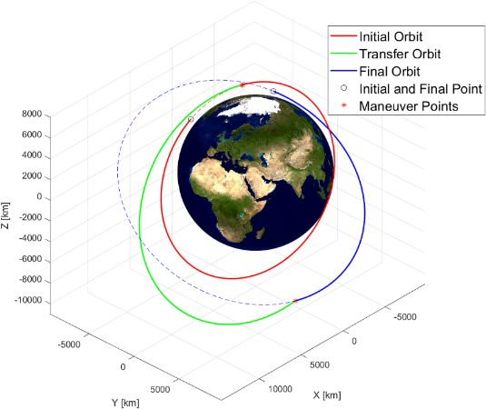

Figure 14 - Secant strategy with minimised $Δv$

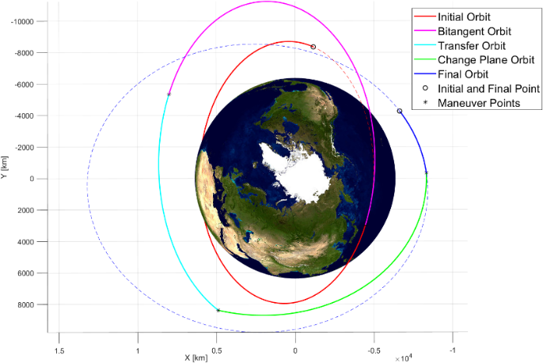

Figure 15 - Another point of view of the strategy S.1

|  |  |
| --- | --- |
| Figure 16 - Plot S.2 | Figure 17 - Plot S.3 |
| Figure 18 - Plot S.4 | Figure 19 - Plot S.5 |
| Figure 20 - Plot S.6 | Figure 21 - Plot S.7 |

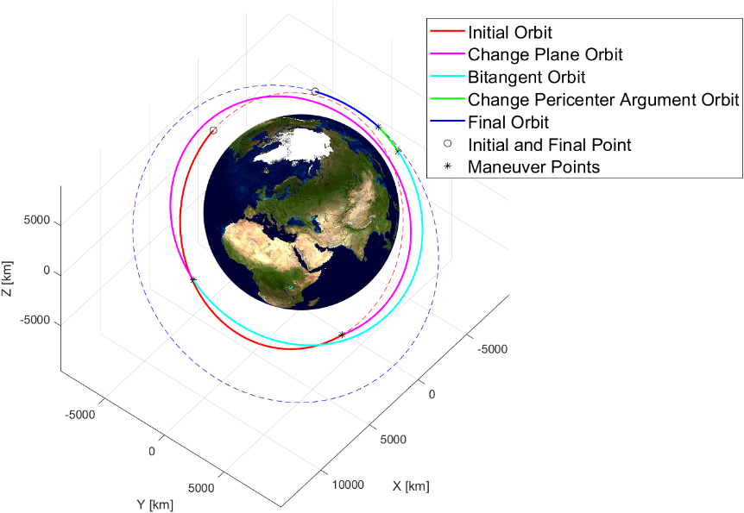

Figure 22 - Plot S.8